1st 13 mark

An embedded system is a specialized computer system designed to perform specific dedicated functions or tasks within a larger system. These systems are typically embedded into other devices or products and serve a particular purpose. Here are some key characteristics and considerations related to embedded systems:

1. \*\*Dedicated Functionality\*\*: Embedded systems are built to perform one or a few specific tasks, often in real-time. Examples include the control systems in appliances, automotive engine control units, and medical devices.

2. \*\*Hardware-Software Integration\*\*: These systems tightly integrate hardware and software to efficiently execute their functions. The software is usually tailored for the specific hardware platform.

3. \*\*Resource Constraints\*\*: Embedded systems often have limitations in terms of processing power, memory, and storage. Developers must optimize their code to operate within these constraints.

4. \*\*Real-Time Operation\*\*: Many embedded systems require real-time operation, meaning they must respond to inputs or events within strict timing constraints. This is critical for applications like robotics and automotive safety systems.

5. \*\*Low Power Consumption\*\*: Power efficiency is crucial, especially for battery-powered embedded systems like smartphones or IoT devices. Minimizing power consumption extends battery life.

6. \*\*Reliability and Stability\*\*: Embedded systems are often used in critical applications where reliability is paramount. Failure can have serious consequences, so extensive testing and redundancy may be employed.

7. \*\*Custom Hardware\*\*: In some cases, custom hardware components or microcontrollers are used to optimize performance for specific tasks.

8. \*\*Development Tools\*\*: Specialized development tools and programming languages may be used for embedded system development. Common languages include C, C++, and assembly language.

9. \*\*Safety and Security\*\*: In industries like automotive and healthcare, embedded systems must meet strict safety and security standards to protect users and data.

10. \*\*IoT Integration\*\*: Many modern embedded systems are part of the Internet of Things (IoT), allowing them to connect to networks and exchange data with other devices and systems.

Embedded systems play a crucial role in various domains, from consumer electronics to industrial automation and beyond. They are hidden from the user but are essential components of everyday life, making devices and systems more efficient and capable.

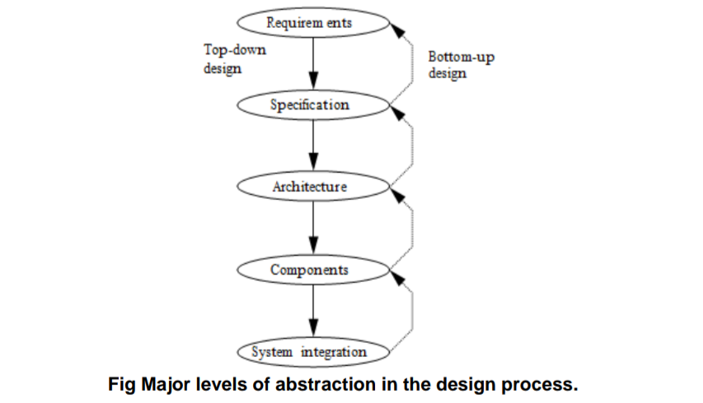

The essential hardware components of an embedded system are:

\* \*\*Processor:\*\* The processor is the "brain" of the embedded system and is responsible for executing instructions and controlling the other components. The selection criteria for the processor will depend on the specific requirements of the embedded system, such as the required performance, power consumption, and cost.

\* \*\*Memory:\*\* Memory is used to store the program code and data that the processor needs to execute. The selection criteria for memory will depend on the size and complexity of the embedded system, as well as the required performance and power consumption.

\* \*\*Power supply:\*\* The power supply provides power to the embedded system. The selection criteria for the power supply will depend on the power requirements of the embedded system, as well as the form factor and environmental constraints.

\* \*\*Input/output (I/O) peripherals:\*\* I/O peripherals allow the embedded system to interact with the outside world. Some common I/O peripherals include sensors, actuators, displays, and communication ports. The selection criteria for I/O peripherals will depend on the specific requirements of the embedded system.

In addition to these essential components, an embedded system may also include other hardware components, such as:

\* \*\*Timers and counters:\*\* Timers and counters are used to generate timing signals and measure elapsed time.

\* \*\*Communication interfaces:\*\* Communication interfaces allow the embedded system to communicate with other devices. Some common communication interfaces include serial, parallel, and wireless interfaces.

\* \*\*Expansion ports:\*\* Expansion ports allow additional hardware to be added to the embedded system.

The selection criteria for all of the hardware components in an embedded system must be carefully considered to ensure that the system meets the required performance, power consumption, and cost constraints.

Here are some additional selection criteria to consider when choosing hardware components for an embedded system:

\* \*\*Temperature range:\*\* The embedded system will need to operate reliably in the temperature range in which it will be used.

\* \*\*Shock and vibration resistance:\*\* The embedded system will need to be able to withstand the shock and vibration that it will encounter during operation.

\* \*\*Electromagnetic interference (EMI):\*\* The embedded system will need to be able to operate in an environment with EMI.

\* \*\*Cost:\*\* The cost of the hardware components must be within the budget for the embedded system.

By carefully considering all of the selection criteria, engineers can design embedded systems that meet the required performance, power consumption, cost, and environmental constraints.